**AN ANALYSIS INTO FUN SPORTS IN KENYA.**

BY

GEOFREY NYABUTO

ANTHONY KHAJIRA

MERCY KIMAKU

A Proposal submitted in partial fulfilment of the requirements of the Degree of Masters of Science in Mobile Telecommunication and Innovation.

(Msc.MTI)

**Faculty of Information Technology.**

**Strathmore University.**

**Nairobi, Kenya**

**September 2016**

**Chapter1: Introduction**

1.1 Background of the study.

Kenya is one of the founding nations of the East African Community and sports have been part of the nation’s culture since its prehistory. Kenyans are known to be very welcoming people and sports provide a great platform where people get to interact and socialize, through sports Kenyans are able to reconnect with their past, connect with their present and also use sports as a means to get international acknowledgement. (kenya.htm, 2016)

Some of the traditional sports in Kenya include wrestling, racing, hunting and even board games. In the recent past football has gained great popularity in Kenya because of the emergence of betting sites. Although Kenyans are known to like the sport our national football team, Harambee stars has not made that much of an impact in the international stage. With all of the sports played in Kenya, one in particular has put the country’s name on the map and that is athletics, track and field to be specific. There are a lot of Kenyans who have made a name for themselves such as David Rudisha, a World Record Holder for 800m and is one of the most dominant world champions. Kenya has racked up an impressive medal count in the Olympic Games thanks to its runners and Kenya is also a world power when it comes to long distance running with roster of world record holders. (kenya.htm, 2016)

As a great sporting nation, there is a lot more on offer to the sporting enthusiast. Most world sports – golf, football, rugby and cricket, to name a few - have taken root in Kenya and are fast growing in their popularity and participation. As such, Kenya is now a sports safari destination where one can enjoy: golfing on some of the world’s most beautiful courses, diving in the lovely tropical waters at the coast, rugby action at the Safari Sevens Rugby tournament, high-altitude training camps and much, much more. (sports, 2016)

**Sports Kenya (SK)** is a state corporation established by the Sports Act, 2013 and given the mandate to carry out functions formally performed by Sports Stadia Management Board and the Department of Sports. The key aim for its formation was to promote, co –ordinate and implement national and international sports programs, establish, manage, develop and maintain the sports facilities including convention centers, indoor sporting and recreational facilities in the country and participate in the promotion of sports tourism among others. (sports-kenya-structure, 2016) **. The Sports Kenya hopes to popularize the other sports and give a chance for sport enthusiasts to make Kenya known for so much more than just athletics.**

**1.2 Problem statement**

Kenya is a great sporting nation and is probably best known for her award-winning athletes who scoop several awards at the Olympics and other international meetings worldwide. However, despite athletics being almost synonymous with Kenyan sports, there is a lot more on offer to the sporting enthusiast.

The recently concluded 20th Edition of the Safari Sevens Rugby tournament held on 23rd September 2016 to 25th September 2016, recorded its lowest ever turn out during the weekend despite international teams headlining the two-day event at the Safaricom Stadium, Kasarani (ghettoradio.co.ke, 2016) .This event was well organized but according to some rugby officials it seems that it was not given the necessary publicity that it deserved and thus recorded low turnout from the game lovers.

Sports go a long way in uniting Kenyans and those living within the county’s boarders and thus the need to publicize the different kinds of sports that Kenya offers.

**1.3 Scope of the project**

The project is aimed at encouraging some of the unpopular sports in Kenya and this will be achieved through developing a mobile application that runs on the IOS platform, the application will run on apple devices for example iPhone 6.

**1.4 Limitation of the project**

Apple products are relatively expensive and thus for this project we will test the application using a simulator and not the actual iPhone.

**Chapter2: Literature review**

**2.1 Introduction**

Kenya is a great sporting nation, during the just concluded 2016 Summer Olympics in Rio de Janeiro, Brazil Kenya made it’s nation's fourteenth appearance at the Olympics and managed to scoop 13 medals most of which were won through athletics. (www.standardmedia.co.ke, 2016). Athletics is synonymous to Kenya however Kenya has so much more to offer in terms of sports.

**2.2 SPORTS KENYA**

**Sports Kenya** is a state corporation established by the Sports Act, 2013 and given the mandate to carry out functions formally performed by Sports Stadia Management Board and the Department of Sports. The key aim for its formation was to promote co –ordinate and implement national and international sports programs, establish, manage, develop and maintain the sports facilities including convention centers, indoor sporting and recreational facilities in the country and participate in the promotion of sports tourism among others. Sports Kenya is expected to develop modern sports facilities as well us improve the existing ones.Sports Kenya manages two of Kenya’s premier Sporting Complexes, which is Moi International Sports Centre, Kasarani and Nyayo National Stadium both in Nairobi City.

#### **VISION**

“To be the preferred provider of sport and recreation facilities, services and opportunities in the region.”

#### **MISSION**

“To develop, manage, and market quality sport and recreation facilities, services and programmes.”

“To encourage more stakeholders’ participation in sports and recreation”

#### **CORE VALUES**

**1. Teamwork** - We have embraced an organic structure whose synergies would translate to actualization of our mission and realization of our vision

**2. Dedication** - As a team, we are wholly and totally committed to the realization of our organizational goals and objectives

3. **Customer Focus** - Our clients’ needs as the core force behind our passionate dedication to service delivery. We shall endeavor to respect the diversity of our clients

4. **Dynamism** - We take into cognizance, the dynamic nature of our business hence we shall continuously adapt to the changing paradigms in the market.

**SPORTS KENYA’S CORE FUNCTIONS:**

The functions of Sports Kenya are to:

(a) Promote, co-ordinate and implement grassroots, national and international sports programs for Kenyans, in liaison with the relevant sports organizations and facilitate the active participation of Kenyans in regional, continental and international sports, including in sports administration.

(b) Manage and maintain the sports facilities i.e Moi International Sports Centre, Kasarani, Nyayo National Stadium and any other facilities which the Cabinet Secretary may declare to be sports facilities through a gazette notice

(c) Establish, manage, develop and maintain the sports facilities, including convention centers, indoor sporting and recreational facilities.

(d) Establish and maintain a sports museum; participate in the promotion of sports tourism;

(e) Create awareness on the benefits of regular participation in sports for healthy living and provide advisory and counseling services to athletes;

## ****2.3 SPORTS IN KENYA****

**2.3.1 MOTOR SPORTS**

Motor sporting is well loved in Kenya, and includes motor cross for the younger generation, motor rallying, off-road racing and go-karting. Chaka ranch is well known for Motor racing sports and offers a nice location for motor racers to enjoy themselves as they race on the tracks.

Motor racing also incorporates the safari rally. This world-famous rally is the only African event on the World Rally circuit, and is without doubt the toughest of the 14 international rally courses. The first rally was held in 1953 to celebrate the coronation of Queen Elizabeth, and the race has since then become an annual event. The promise of the world's most grueling race brings many international drivers to Kenya, and the race is broadcast to a television audience of millions. (www.kenyabrussels.com, 2016)

Rhino charge is also a game that falls in the motor sports category and is greatly enjoyed. The annual Rhino Charge is a local event that is aimed at raising money for conservation and protection of Kenya’s mountain range ecosystems, the so called “Water Towers”. Rhino Charge is a 4WD-rally through the wilderness of the Laikipia region of Kenya. The race involves 4WD-vehicles following a course through extremely rough terrain to reach a series of pre-arranged points in the fastest possible time. (about, 2016). The course is designed with challenge in mind, and each year these off-road vehicles are pushed to their absolute limits. The Rhino Charge vehicles are crewed by a full team of driver, navigator and support crew. The race is definitely a light-hearted affair and is a social event in itself. Large camps are set up to support the race, and these are the venue for both pre and post-race celebrations. (www.kenyabrussels.com, 2016)

**2.3.2 WATER SPORTS**

Water sports of all types are available in Kenya. The warm seawater is ideal for swimming, with none of the health risks that inland waters have. Windsurfing, parasailing, water-skiing and jet-skiing are available at many coastal resorts and clubs. Also available is yachting, sailing, boating, kayaking and white-water rafting. The thrills of white-water rafting can be experienced at the Rapid Camp in Sagana. This sport brings people from all walks of life and gives them a great opportunity to connect and enjoy the beauty of nature. (www.kenyabrussels.com, 2016)

Sports Kenya has been in the forefront in encouraging the adoption of swimming as a sport in Kenya. Sports Kenya manages the Kasarani Aquatic Stadium, the facility has one Baby pool; 1.25m deep Warm-up or training pool; 1,5m deep Competition (Olympic size) pool and 6m seminar room with 30pax capacity and a VIP Lounge. Sports Kenya ensures that the pools are clean, properly treated and well maintained and thus swimming enthusiast have a nice place to enjoy the sport. (sports-kenya-structure, 2016)

**2.3.3 PAINTBALL**

Paintball is a game developed in the 1980s in which players eliminate opponents from play by hitting them with dye-filled, breakable, oil and gelatin paintballs, or pellets, usually shot from a carbon dioxide or compressed air (Nitrogen) powered “paintball marker”. The game is regularly played at a sporting level with organized competition involving major tournaments, professional teams, and players**.** The game can be played on indoor or outdoor fields of varying sizes. A game field is scattered with natural or artificial terrain, which players use for tactical cover. Some of the games played during a paintball game vary, but can include capture the flag, elimination, ammunition limits, defending or attacking a particular point or area, or capturing objects of interest hidden in the playing area. Depending on the variant played, games can last from seconds to hours, or even days in scenario play.

During a paintball game the players are required to wear protective masks, and game rules are strictly enforced. Paintball is a new sport in Kenya and currently it can only be played at the Jamhuri Park. Paintball is a fun sport and more publicity should be given to it so that more people can get to know about it and get to enjoy it with their friends.

**Conclusion.**

Kenya has a broad appeal. There is everything for everyone in regards to sports, for motor lovers they can take part in motor races, swimmers can enjoy the nice sunny afternoon swimming sessions and those who like to try out new things, can take time and play paintball with their friends and colleagues. Sports offer a great opportunity for people to interact and make friends. These fun sports can also be looked at as a means to earn international recognition in the event that the players organize for international tournaments. This project’s deliverable is a mobile application that runs on the iPhone Operating System (IOS). The mobile application will enable sport enthusiast to see the various sports on listing, see the sports events planned, join the events and get a chance to engage in them and later on send photos of the special moments captured during the event. This application aims at encouraging more people to engage in the various sports and also offer a place to advertise the sports that are not well known.

**Chapter3: System design**

**Introduction**

This Chapter describes the system design that was implemented in the creation of the FunSport mobile application that runs on the IOS platform. Wireframes were used in coming up with the design of the application and served as a guide when developing the final product.

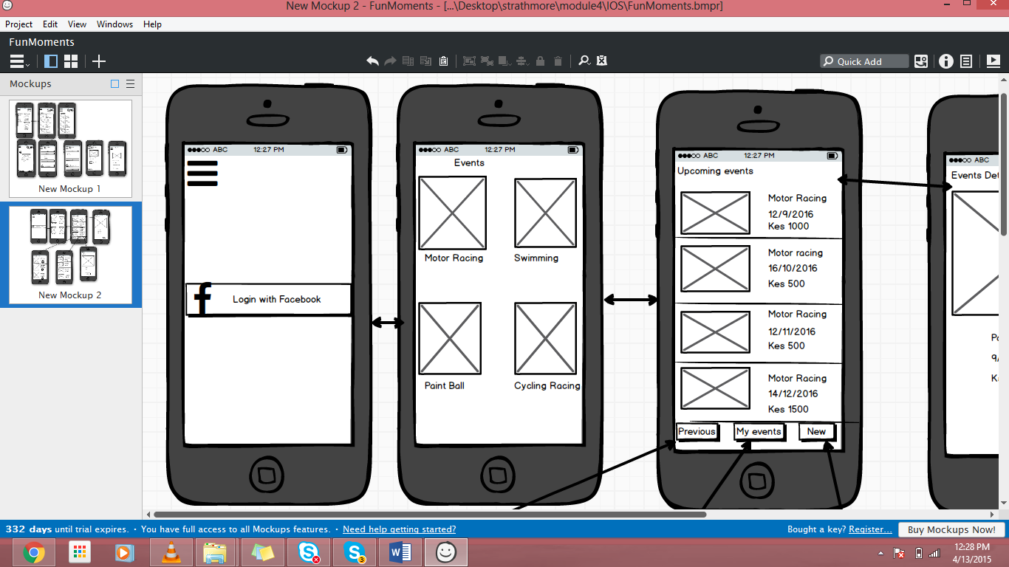 

Login Page Home Page

 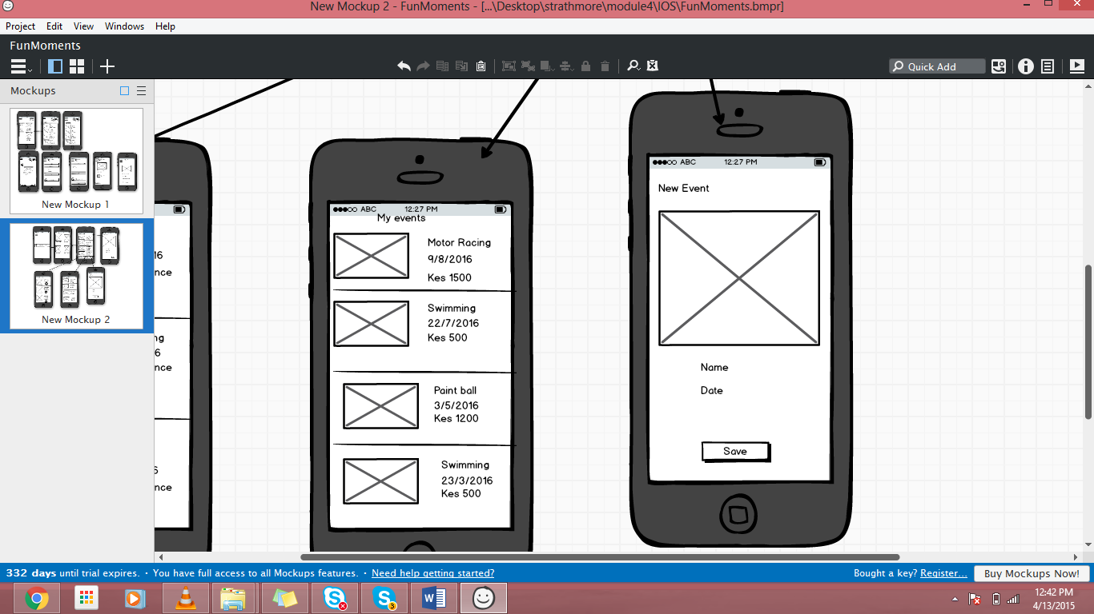

Upcoming Events Page New event page



# References

(2016, September 29). Retrieved from ghettoradio.co.ke: http://ghettoradio.co.ke/omwela-safari-7s-low-turn-out-is-a-result-of-sabotage/

(2016, September 29). Retrieved from www.standardmedia.co.ke: http://www.standardmedia.co.ke/sports/article/2000212862/rio-games-kenya-tops-african-medal-table

(2016, September 29). Retrieved from www.kenyabrussels.com: http://www.kenyabrussels.com/index.php?menu=2&leftmenu=43&page=53

*about*. (2016, September 29). Retrieved from www.rhinocharge.co.ke: http://rhinocharge.co.ke/about/

*kenya.htm*. (2016, September 29). Retrieved from www.topendsports.com: http://www.topendsports.com/world/countries/kenya.htm

*sports*. (2016, September 29). Retrieved from www.kenyabrussels.com: http://www.kenyabrussels.com/index.php?menu=2&leftmenu=43&page=53

*sports-kenya-structure*. (2016, September 29). Retrieved from www.sportskenya.org: http://www.sportskenya.org/index.php/financing/sports-kenya-structure